**How do I export my conversations? From Where To Obtain Data?**

* The first step is **Data Retrieval & Preprocessing**, that is to **gather the data**. WhatsApp allows you to **export your chats** through a **.txt format**.
* Go to the respective chat, which you want to export!

[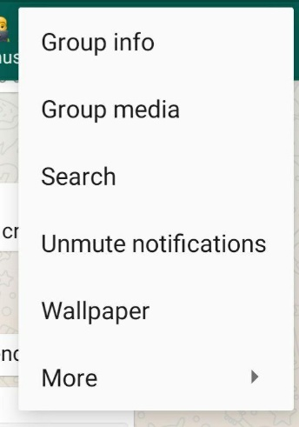](https://github.com/tusharnankani/whatsapp-chat-data-analysis/blob/main/assets/extras/whatsapp-options.jpg)

* Tap on **options**, click on **More**, and **Export Chat.**

[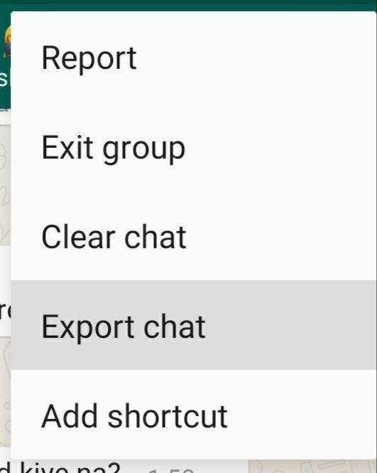](https://github.com/tusharnankani/whatsapp-chat-data-analysis/blob/main/assets/extras/whatsapp-export-chat.jpg)

* I will be Exporting **Without Media.**

[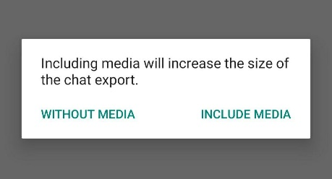](https://github.com/tusharnankani/whatsapp-chat-data-analysis/blob/main/assets/extras/whatsapp-media.jpg)

#### NOTE:

* While exporting data, avoid including media files because if the number of media files is greater than certain figure then not all the media files are exported.